A Web-Based Smart Healthcare System with AI-Driven Disease Prediction and Intelligent Appointment Management detection Using Machine Learning

M.Sindhu Lakshanya Murugan Barkavi R
Department of Computer Science & Engineering Department of Computer Science & Engineering Department of Computer Science & Engineering
Chennai Institute of Technology Chennai Institute of Technology Chennai Institute of Technology
Kundrathur , Chennai – 600069 , TN , India Kundrathur , Chennai – 600069 , TN , India Kundrathur , Chennai – 600069 , TN , India
sindhum@citchennai.net lakshanyamurugan.cse2022@citchennai.net barkavir.cse2022@citchennai.net

Abstract— The rapid growth in online healthcare solutions demands the design and development of smart, secure, and user-friendly systems to engage more patients and improve clinical effectiveness. This paper presents a Web-based Smart Healthcare System to support patients by automating appointment scheduling, managing prescriptions, predicting diseases based on symptoms presented, and intelligently recommending doctors. The designed system will use Artificial Intelligence combined with a full-stack web platform for end-to-end healthcare service delivery in real time.

The system includes an AI-enhanced disease predictor and a symptom checker with a chatbot to provide patients with preliminary medical advice concerning the symptoms they input into the platform. A role-based access control system helps provide safe exchanges among patients, doctors, and administrators. The overall architecture is built to be in an architecture that is both modular and scalar using React for frontend; the services are implemented in Node.js/Express; the database is handled by MySQL.

The experimental assessment is carried out by undertaking functional validation of the processes of logging in, work on the dashboard, appointment booking, and AI-driven recommendations with the help of real-time demonstrations of the system. The results reveal that the proposed system performs well in the enhancement of accessibility, reduction of manual intervention, and informed decision making about healthcare service delivery. This can allow showing how the AI-assisted web applications may change modern healthcare services.

Keywords- Smart Healthcare System, Web Application, Disease prediction, Chatbot, Appointment Scheduling, Role-based access control, Full stack development, Artificial Intelligence.

I. INTRODUCTION

The whole healthcare sector is increasingly being transformed by the incorporation of digital technologies and intelligent systems. The old system of healthcare can be characterized by manually booked appointments, incomplete patient history, and delayed medical care, and this may result in inefficiencies and decreased patient
satisfaction. As the accessibility to web technologies and

Artificial Intelligence grows, so does the possibility of creating an intelligent healthcare platform that would increase accessibility, accuracy, and operational efficiency.

The Web-based healthcare systems are important in ensuring the patients can communicate with the medical services remotely. Online booking of appointments, management of prescriptions online, and automated health advice are some of the features that make administrative work less demanding and enhance patient interactions. However, AI-driven disease forecasting and symptom assessment based on chatbots can also offer medical knowledge at an earlier stage and help the patient before the clinical diagnosis.

This paper proposes a Smart Healthcare System that integrates a full-stack Web application with an AI-based disease prediction and intelligent symptom analysis. The functionalities of the system mainly centre around the patient, thereby allowing a user to manage medications, consult doctors, and thus avail early medical advice using the single dashboard. The proposed platform will have a role-based access control of patients, doctors, and administrators, which provides protection and puts order in data management.

The primary aim of this research work is to develop, design, and test an healthcare platform that can be scaled up for increasing medical accessibility while retaining its reliability, security, and usability.

II. LITERATURE SURVEY

The growth in information technology and artificial intelligence has been a contributing factor in the structural change that is occurring within the medical industry.. Much more attention was paid to research topics associated with uniting such technologies as the web, machine learning, and intelligent automation for improving access to healthcare, its efficiency, and the accuracy of decision-making.

The World Health Organization considers the role of the digital health system crucial for improving healthcare infrastructure in increasing the involvement of patients, data management, and service provision. Online consultation services and electronic health records are some of the examples of digital interventions that have been successful in reducing manual workload and increasing access to healthcare services, especially in rural areas [1], [2].

AI has lately become a revolutionary technology in the field of healthcare usage. As Esteva et al. showed, deep learning models can perform like experts in identifying a disease if trained on large medical datasets [4]. On the same note, the authors of Jiang et al. showed the application of AI in predictive analytics, early disease diagnosis, and treatment planning, which is likely to transform the practice of contemporary healthcare [5].

Several studies have been conducted on machine learning with respect to disease prediction. Wagholikar et al. developed the automated disease prediction paradigm through supervised learning algorithms. This lets notable advances in the accuracy of the diagnosis be achieved [11]. Manogaran et al. tested several machine learning models in the task of classifying diseases and found that the data-driven models have a potential to help clinicians with initial predictions made with a high degree of reliability [15]. The problem is that most of them cannot be smoothly integrated with the real-time web platform.
Due to the provision of real-time healthcare advice, the use of chatbots as healthcare support has been noticed. In their work, Hussain et al. developed a medical chatbot that helps patients based on the analysis of symptoms and recommendations on healthcare [7]. Divya and Subhashini also established the fact that chatbots programmed using AI enhance interaction between users and decrease the time response in a healthcare setting [8]. Even though these chatbot systems are effective, they are commonly introduced as stand-alone applications and not as an integrated healthcare platform.

Web-based health care management systems have been suggested to improve the operations of the hospitals and their communication with the patients. Kumar et al. created a web-based platform of healthcare management system which assists in patient records and booking of appointments [14]. This was introduced by Gupta and Shukla, who introduced an online appointment system that minimized waiting time and improved the efficiency of the workflow in the hospital [19]. These systems have very little intelligent decision-support features and quite a lot administrative features.

The aspect of security and access control is very critical in healthcare systems because medical data are sensitive. The proposed Ramesh et al. role-based access control models are specific to healthcare settings that will guarantee the safety of data access among patients, physicians, and administrators in healthcare facilities[16]. Though effective, it is difficult to combine such security with AI-based healthcare platforms.

The recent surveys by Dash et al. and Sahoo et al. discussed the machine learning and AI in healthcare systems, issues regarding data privacy, system scale, and complexity of integration [17], [20]. The above studies identify the integration of smart platforms with user-friendly web interfaces as key to improvements.

The literature shows there are many solutions that cater to individual areas in the healthcare sector, which include the prediction of illnesses, chatbots, or scheduling of appointments. Yet, no fully integrated smart healthcare systems have been established where all these features are incorporated into a single scalable, web-based secure solution. This paper fills this gap through coming up with a comprehensive Smart healthcare System, which shall incorporate the use of AI in predicting diseases, a chatbot for symptoms analysis, Role-Based Access Control, and online appointment scheduling into one full-stack web app.
III. SYSTEM OVERVIEW

The proposed Smart Healthcare System is a web-based application, which strives to help a patient with the aid of intelligent healthcare services. The system follows a client-server architecture and has associated elements of frontend, backend, database, and AI aspects.

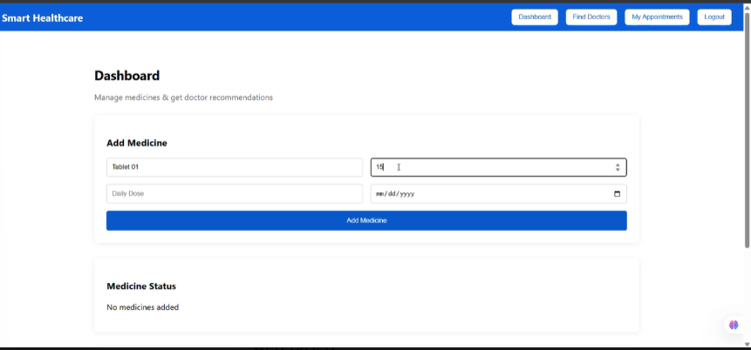

A. User Roles
The System provides the facility of interaction through three primary user roles: a Patient, a Doctor, and an Administrator. The patients will be given a fully functional interface for signing up and securely logging in, while they will also be able to manage their health by performing symptom checks, booking appointments, and requesting medication. The doctors get a simplified dashboard view to check their appointment schedules and go through the chief complaints of the patients before consultancy. Lastly, the Administrator is the controller of the whole system, which manages the profiles of doctors, keeps a record of all the users, and changes different system-level configurations for smooth working.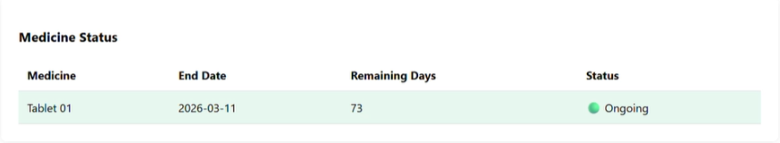

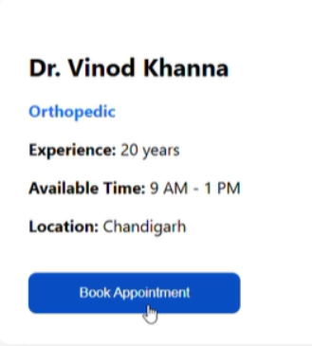
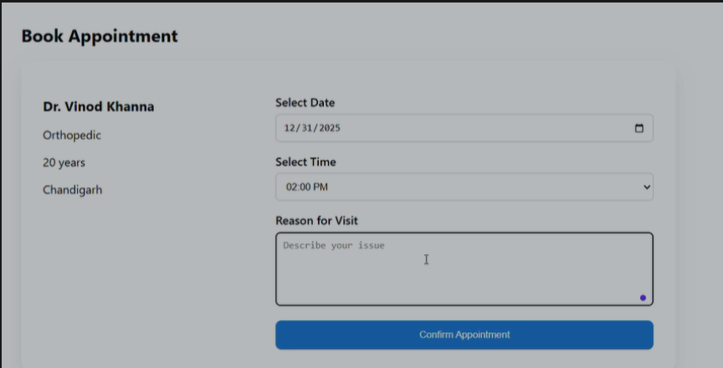

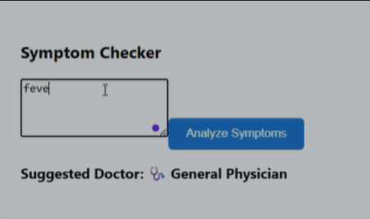

B. Core Functional Modules:
1. User Authentication and Secure Flow User authentication:
Performed through role-based redirection. Once the login is successful, the user gets automatically redirected to their respective interfaces (Patients, Doctors, or Administration).
2. Patient Dashboard:
The patient dashboard is a central place where patients can see their health care management. They can easily access the necessary tools such as the medication management feature and the symptom checker tool.
3. Online Appointment Booking:
Patients have the ability to search for doctors depending on their specialty, location, and schedule. The module enables an instant booking process with a mandatory requirement to state the reason for consultation.
4. Disease Prediction by AI:
Using a logical model of AI, this feature tries to predict diseases based on the reported symptoms. The result gives a prediction of the diseases a patient may have based on the symptoms.
5. Chatbot Symptom Scanner:
This text-based chatbot interacts directly with the patient. It evaluates symptom combinations. Depending on input given by the patient, it scans all signs and symptoms entered and accordingly identifies the kind of ailment and the specialty under which it should be treated.
6. Prescription Management:
This module helps patients record their doses of prescription medication to ensure compliance. This system will track “days left” for prescription medication to remind patients not to miss doses.

IV. TECHNOLOGY STACK

- Frontend:
React is utilized in creating the dynamic user interface for the Patient Dashboard, that enables smooth user interaction with the symptom checker and the appointment system.
- Backend:
Node.js with Express Acts as a powerful server-side platform to handle requests to APIs, authenticate users’ login sessions, and perform logic operations.
- Database:
MySQL is employed for safe storage of structured information, like, patient records, appointments, and medication.
- API Testing:
Postman is used for testing the reliability of the APIs by ensuring the smooth communication of the data, from the client to the server.
- AI Model:
- Chatbot Logic:
Incorporates natural language processing logic to navigate patients through symptom triage.
- Disease Prediction Model:
This component enables the execution of logical algorithms to examine the symptom information entered by the patient. These algorithms forecast an individual’s health status.

V. SYSTEM ARCHITECTURE AND METHODOLOGY

The proposed Smart Healthcare System is actually based on the 'Layered-Client-Server' architecture, so it assures scalability, modularity, and safety of operation with data. The system comprises a frontend presentation logic, a backend business logic, and database storage and artificial intelligence analytical components.

A. Architectural Design:
The four major layers in the architecture include:

- Presentation Layer (Frontend):
Frontend: React.Js is used in the frontend's development to help create a responsive user experience. This layer manages user interactions, such as logging in, navigating the dashboard, scheduling an appointment, entering symptoms, and seeing a prescription.
Application Layer Backend Services: The backend is developed on the basis of Node.js with Express, which handles requests, performs authentication and role authorization, business logic, and talks with the database and AI modules.
- Data Layer (Database):
MySQL is the relational database system that will store structured health care data such as user profiles, doctor details, appointments, prescriptions, and medical history.
- AI Processing Layer:
This layer can be used to predict a disease and analyze the symptoms through a chatbot. The symptoms entered by the users are processed and compared to the disease patterns to allow intelligent healthcare recommendations.

VI. FUNCTIONAL MODULES:

A. Role-Based Access Control and User Authentication:
The RBAC is also implemented as an efficient security system that has secure authentication mechanisms combined with strict role-based authorizations. After completing the authentication process, users are redirected to respective interfaces based on their levels of access. Patients are redirected to their respective dashboards, while doctors can view their schedules, and administrators are given control panels where they can control data at an organizational level. Such detailed access control further secures the platform by making it impossible for people to access any private healthcare information.

B. Patient Dashboard:
This is used as a patient-centric device that forms the basis for:
- Record and monitor prescribed medication.
- Time it and track the days left of medication.
- Access the symptom checker
- Manage and view booked appointments.
It is a unified interface that enhances usability and patient interaction.

C. Booking of appointments through Online:
Patients can be able to search the available doctors by filtering their specialization, experience, place, and time. The appointment booking module will enable the user to:
- Select a preferred doctor
- Choose date and time slots
- Provide a reason for visit
- Electronic confirmation of appointments.
This helps in the elimination of manual scheduling and minimization of waiting time.

D. A.I.-based disease prediction:
The disease prediction module functions as a sophisticated logical model using artificial intelligence techniques. The module is capable of analyzing the symptoms entered by the patient and using the data to come up with health inputs. Through the advanced algorithms used in the system, the module is not only useful in the early prediction of diseases but also helps the user by suggesting the appropriate types or categories of medicine related to the user's needed help. Most importantly, the module provides non-diagnostic suggestions useful as a launching tool in the decision-making process for the user. This module gives the user the benefit of identifying health problems and analyzing them from the onset so that the user can have a full understanding of his or her health status before visiting the doctor.

E. Chatbot-Based Symptom Checker:
The Chatbot System for Symptom Checking functions as a smart communication interface, that helps to improve real-time communication between the system and patients. The system validates and processes symptom checking data from patients, to make informed decisions using pattern analysis to identify the type of health concerns. Consequently, it provides informed suggestions regarding medical specialties, to refer patients to relevant healthcare professionals. This automation aspect helps to improve system accessibility by providing patients with immediate health support services at any time.

F. Prescription Management:
The Prescription Management module enables the patients to be empowered and in charge of their medicines, as the module records the prescribed medicines, the respective doses, as well as the time period of the medicines. By providing automatic calculations, for the number of days left for completion of the entire treatment process, this module helps prevent the chances of missed doses being significantly low.

VII. IMPLEMENTATION DETAILS

React provides the frontend user interface, which is developed using a component-oriented approach for designing reusable user interfaces, in combination with state management concepts, for facilitating the real-time updating of dashboards, forms, and appointments. Additionally, the frontend interacts with Node.js/Express APIs developed for providing RESTful APIs related to user login, appointment management, symptom analysis, as well as preserving prescriptions, which are validated for their reliability using Postman. Moreover, for managing the data components, a MySQL database schema is developed, which is organized in such a way as to provide relational constraints on patients, doctors, timelines, as well as prescriptions, respectively, by using indexing.

VIII. RESULTS AND DISCUSSION

The system was tested on the basis of functional validation and real time execution as shown through the working model. Some of the workflows that are tested are:
- Dashboard navigation: based on roles and logins.
- Reservation of appointments and confirmation.
- Chatbot response and prediction of a disease.
- Medicine tracking and status updates.
The findings also disclose that the system:
- Automates successful healthcare processes.
- Gives proper and timely prescriptions by the doctor.
- Improves patient experience using AI.
- Stores information in a safe and orderly manner
Engagement of the user and initial healthcare consultation become improved quite effectively with the usage of AI modules.

IX. CONCLUSION AND FUTURE SCOPE

This paper presented a web-based Smart Healthcare System using the full stack web technology, disease prediction system, and intelligent symptom analyzer which is fueled by AI. It is effective in supporting the patient through the automated booking system, the prescription management system, and finally the chatbot system. It is also secure through the role-based login system.
The result of the experiment has indicated a better accessibility of healthcare services, minimal human intervention, and patient interaction. The system has also shown the possibilities of uniting the worlds of Artificial Intelligence and web technology in an effort to modernize the healthcare delivery process.

Future Enhancements
Future enhancement will be done by incorporating high-level machine learning models for increasing accuracy in disease prediction, along with developing a mobile application for users on portable devices. The infrastructure of the system is build to be cloud native to address scalability, Security and integration of EHRs will be prioritized to provide a unified and comprehensive medical history for each patient.

X. ACKNOWLEDGMENT

The contributors are ever grateful for the support provided in the development and evaluation of the above Project. They wish to acknowledge the invaluable support and help they received from their supervisor in the development stage of the Project and from the institution that provided the required infrastructure facilities to accomplish the Project. They are also grateful for the constant support of their family and friends.

XI. REFERENCES

- WHO Guideline: Recommendations on Digital Interventions to Strengthen the Health System, Geneva, Switzerland, 2019.
- World Health Organization, Digital Health, WHO, 2023. [Online]. Available: https://www.who.int/health-topics/digital-health
- R. S. Khandpur, Healthcare Information Systems: Concepts and Technologies, McGraw-Hill, 2018.
- A. Esteva et al., Nature Medicine, vol. 25, no. 1, pp. 24-29, 2019, "A guide to deep learning in healthcare.
- J. Jiang et al., "Artificial intelligence in healthcare: Past, Present and Future," Stroke and Vascular Neurology, vol. 2, no. 4, pp. 230-243, 2017.
- S. Patel, A. Patel, and D. Patel, Role of information technology in healthcare, International Journal of Advanced Research in Computer Science, vol. 8 no. 6, pp. 56-60, 2017.
- M. Hussain, M. Afzal and W. Ahmad, Chatbot design in medical support, International Journal of Advanced Computer Science and Applications, vol.10, no.12, pp.14-20, 2019.
- A. Divya and N. R. Subhashini, "AI-based chatbot in healthcare applications: Procedia Computer Science, vol. 167, pp. 234-243, 2020.
- S. Minaee et al., Deep learning-based text classification: A comprehensive review, ACM Computing Surveys, vol. 54, no. 3, pp. 1- 40, 2021.
- D. W. Bates et al., Big data in health care: Using analytics to find and manage high-risk patients, Health Affairs, vol. 33, no. 7, pp. 1123-1131, 2014.
- K. B. Wagholikar et al., Automated disease predicting with machine learning, IEEE Journal of Biomedical and Health Informatics, vol. 23, no. 4, pp. 1804-1814, 2019.
- R. Miotto et al., "Deep learning in healthcare: Review, opportunities and challenges, Briefings in Bioinformatics, vol. 19, no. 6, pp. 1236-1246, 2018.
- P. Verma and S. Sood, "Cloud-based IoT discretionary disease diagnosis healthcare system," Journal of Parallel and Distributed Computing, 117, pp. 27-38, 2018.
- N. Kumar, K. Kaur, and S. Kumar, "Web-based healthcare management system," International Journal of Computer Applications, vol. 162, no. 4, pp. 7-11, 2017.
- J. K. Manogaran et al., "Machine learning algorithm based disease prediction," Computers & Electrical Engineering, vol. 81, 106-117, 2020.
- A. Ramesh et al., Role-based access control models of a healthcare system, IEEE Access, vol. 8, pp. 164392-164404, 2020.
- S. K. Dash, S. Mohapatra and P. K. Pattnaik, "A survey of machine learning applications in healthcare," International Journal of Computer Science and Engineering, vol. 5, no. 6, pp. 341-347, 2018.
- T. Davenport and R. Kalakota, The potential of artificial intelligence in healthcare, Future Healthcare Journal, vol. 6, no. 2, pp. 94-98, 2019.
- A. Gupta and R. Shukla, "Online appointment scheduling system of hospitals," International Journal of Engineering Research and Technology, vol. 9, no. 3, pp. 112-116, 2020.
- P. K. Sahoo et al., "Machine learning-based healthcare systems: A survey," IEEE Reviews in Biomedical Engineering, vol. 14, pp. 242-254, 2021.
- E. Topol, Deep medicine: how artificial intelligence can make healthcare human again, Basic Books, 2019.
- L. Wang, Z. Zhang, X. Zhang, X. Zhou, and P. Wang, A deep forest-based approach to detect the fraudulent healthcare data, IEEE Access, vol. 8, p. 124536-124547, 2020.
- S. R. Bhatia and R. Kaur, "Intelligent healthcare monitoring system with machine learning," International Journal of Engineering and Advanced Technology, vol. 9, no. 3, pp. 1220-1225, 2020.
- M. Chen, Y. Hao, K. Hwang, L. Wang, and L. Wang, "Machine learning to predict diseases with big healthcare data," IEEE Access, vol. 5, pp. 8869-8879, 2017.
- A. Islam, A. Rahman and M. S. Hossain, "AI-based healthcare chatbot in disease prediction, Procedia Computer Science, vol. 167, pp. 243-252, 2020

